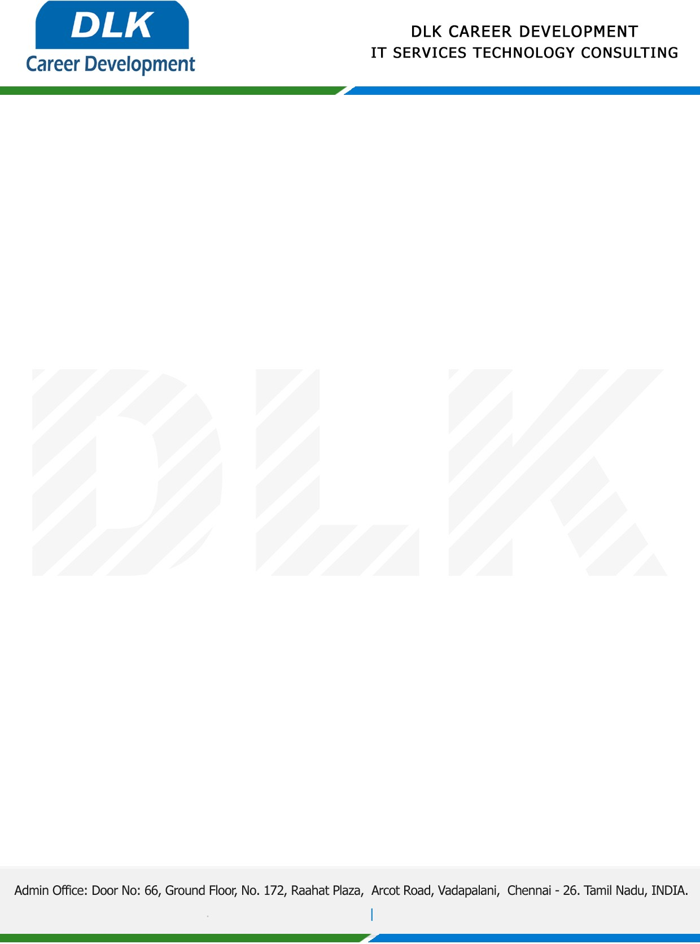

Date: 23 / December/ 2022

**To**

Department of BE –Computer Science Engineering,

Head of Department,

Velammal Engineering College, Chennai-600066.

**Sub: Letter of Internship Acceptance**

This is to certify of pre-final year student of has accepted his Internship Work duration from **26th December 2022** to **13th January 2023** under the domain **“Web Development”.** During the internship, all information and data collected from you should be kept confidential.

**Name List:-**

1. MR VASANTH M (REG NO: 113220031161)
2. MR SAKTHI DHASAN B (REG NO: 113220031114)
3. MR RAGHUL S (REG NO: 113220031103)
4. MR SRIRAM S H (REG NO: 113220031141)
5. MR SYED MUIZ AHMED S (REG NO: 113220031153)
6. MR SANJAY K (REG NO: 113220031117)
7. MR AIJAY RAMANUJAM G (REG NO: 113220031007)
8. MS NAVEENAA S (REG NO: 113220031083)
9. MR YUVAN SANKAR RAJA.S(REG NO: 113220031171)
10. MR MANOJ J B(REG NO: 113220031074)
11. MR LOGESH K(REG NO: 113220031069)

We appreciate your interest in **DLK CAREER DEVELOPMENT**

